Cloud Application Development

Project Design Phase – 2

Technology Architecture

|  |  |
| --- | --- |
| Team ID | PNT2022TMID45523 |
| Project Name | Customer Care Registry |
| Maximum Mark | 4 Marks |

**TechnicalArchitecture:**

The Deliverable shall include the architectural diagram as below and information

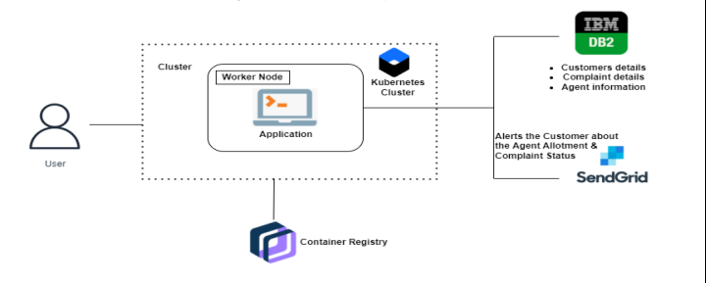

**Table -1: Components & Technologies**

|  |  |  |  |
| --- | --- | --- | --- |
| **S.No** | **Components** | **Description** | **Technologies** |
| 1 | User Interface | How user interacts with application e.g.  Web UI, Mobile App, Chatbot etc. | HTML, CSS, JavaScript / Angular Js /  React Js etc. |
| 2 | Logic-1 | Logic for a process in the application | Python |
| 3 | Logic-2 | Logic for a process in the application | IBM Watson STT service |
| 4 | Logic-3 | Logic for a process in the application | IBM Watson Assistant |
| 5 | Database | Data Type, Configurations etc. | MySQL, NoSQL, etc. |
| 6 | Cloud Database | Database Service on Cloud | IBM DB2, IBM Cloudant etc. |
| 7 | File Storage | File storage requirements | IBM Block Storage or Other Storage  Service or Local Filesystem |
| 8 | Infrastructure (Server / Cloud) | Application Deployment on Local System / Cloud  Local Server Configuration:  Cloud Server Configuration | Local, Cloud Foundry, Kubernetes, etc. used in cloud |
| 9 | External API-1 | Purpose of External API used in the application | Aadhar API, etc. |
| 10 | External API-2 | Purpose of External API used in the application | IBM Weather API, etc. |
| 11 | Machine Learning Mode | Purpose of Machine Learning Model | Object Recognition Model, etc. |

**Table-2: Application Characteristics:**

|  |  |  |  |
| --- | --- | --- | --- |
| **S.No** | **Characteristics** | **Description** | **Technology** |
| 1 | Open-Source Frameworks | List the open-source frameworks used | Python flask |
| **2** | Security Implementations | List all the security / access controls implemented,  use of firewalls etc. | e.g encryption, intrusion detection  software, antivirus, firewalls |
| **3** | Scalable Architecture | Justify the scalability of architecture (3 – tier,  Micro-services) | supports higher workloads without any  fundamental changes to it. |
| **4** | Availability | Justify the availability of application (e.g. use of  load balancers, distributed servers etc.) | High availability enables your IT  infrastructure to continue functioning even  when some of its components fail. |
| **5** | Performance | Design consideration for the performance of the  application (number of requests per sec, use of  Cache, use of CDN’s) etc. | Performance technology, therefore, is a  field of practice that uses various tools,  processes, |